36.39: The best resolution is 0.3 arcseconds, which is about 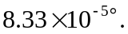
a) 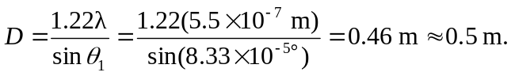
b) The Keck telescopes are able to gather more light than the Hale telescope, and
hence they can detect fainter objects. However, their larger size does not allow them to have greater resolution⎯atmospheric conditions limit the resolution.

